DOS & DONTS
SPECIAL PRE-PLE MOCK 2025

25TH JULY, 2025
SCIENCE
Time Allowed: 2 hours 15 minutes
Random No. |  |  |  |  |  | Personal No.

Candidate’s Name……………………………………………………………………….
Signature……………………………………………………………………………........
School Name: …………………………………………………..…………………………
Read the following instructions carefully:
FOR EXAMINERS’ USE ONLY
QN NO. | MARKS | EXR’S  NO.
1 - 10
11 - 20
21- 30
31 - 40
41 - 43
44 - 46
47 - 49
50 - 52
53 - 55
TOTAL
- This paper has two sections: A and B.
Section A has 40 questions
Section B has 15 questions

2. Answer all the questions. All the working for
both sections A and B must be shown in the
spaces provided.

3. All the working must be done using a blue or
Black ball point pen or ink. Any work done in
Pencil other than graphs and diagrams will
Not be marked.

4. No calculators are allowed in the examination
Room.

5. Unnecessary changes in your work
and handwriting that cannot be read easily may lead to loss of marks.

6. Do not fill anything in the table indicated
“FOR EXAMINERS’ USE ONLY” and in the
boxes inside the question paper.
TURN OVER
SECTION A
1. State one advantage of reflection of light.
………………………………………………………………………………………………………….
2. Give any one danger of having too little ear wax in the auditory canal.
………………………………………………………………………………………………………….
3. Mention one vaccine which is administered in babies at one month and half.
………………………………………………………………………………………………………….
4. What is the role of PMCT in women?
………………………………………………………………………………………………………….
5. State the reason why the composition of exhaled oxygen is less than the inhaled oxygen.
………………………………………………………………………………………………………….
6. How does the brushing of teeth prevent tooth decay?
………………………………………………………………………………………………………….
7. What is the normal body temperature of a person?
………………………………………………………………………………………………………….
8. State one advantage of using a single fixed pulley over a single movable pulley.
………………………………………………………………………………………………………….
9. Which system of a flowering plant contains the leaves?
………………………………………………………………………………………………………….
The diagram below shows a part of the skeletal system. Study and use it to answer questions 10 and 11.
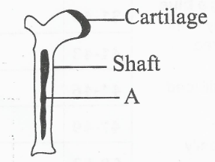

10. How is substance A important to circulatory system?
………………………………………………………………………………………………………….

11. Name the type of bone drawn above.
………………………………………………………………………………………………………….
12. Mention any one danger of clouds in the environment.
………………………………………………………………………………………………………….
13. State what the arrows in the feeding relationship illustrated below show.
Grass Grasshopper Lizard Snake
………………………………………………………………………………………………………….
14. Give the chemical method of controlling mosquitoes from breeding in ponds.
………………………………………………………………………………………………………….
15. How does smoking affect a pregnant woman?
………………………………………………………………………………………………………….
16. State what should be done by a water closet user to prevent blockage of a septic pipe.
………………………………………………………………………………………………………….
17. Which practice in the steps of cleaning clothes prevents some clothes from staining others?
………………………………………………………………………………………………………….
18. Give any one factor that affects the efficiency of a machine.
………………………………………………………………………………………………………….
19. State one way how farmers can protect cattle from causing injuries to other animals.
………………………………………………………………………………………………………….
20. Why is it wrong to say that potential energy is energy possessed by objects at rest?
………………………………………………………………………………………………………….
21. Mention any one danger of refraction of light in our daily life.
………………………………………………………………………………………………………….

22. Write one example of a physical process which requires reduction of heat.
………………………………………………………………………………………………………….
23. State any one importance of a health survey.
………………………………………………………………………………………………………….
24. Identify the group of mammals where a bat belongs.
………………………………………………………………………………………………………….
25. Mention any one way how humans control acto-parasites on their bodies.
………………………………………………………………………………………………………….
26. Give one importance iodine in providing first aid to a casualty.
………………………………………………………………………………………………………….
The diagram below shows parts of the digestive system. Use it to answer 27 and 28.
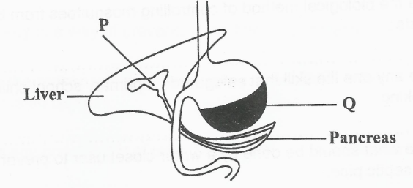

27. Name the mechanical digestion which occurs in part Q.
………………………………………………………………………………………………………….
28. Give the importance of the digestive juice stored in part labeled P.
………………………………………………………………………………………………………….
29. State any one way of increasing the volume of blood in the human body.
………………………………………………………………………………………………………….
30. Give any one way how desert plants reduce the rate of transpiration.
………………………………………………………………………………………………………….
31. State any one activity human skin does to regulate the body temperature on a cold day.
………………………………………………………………………………………………………….
32. Give any one importance of colostrum in cattle management.
………………………………………………………………………………………………………….
33. State any one condition that favours the breeding of bacteria.
………………………………………………………………………………………………………….
34. Give the function of cotyledon in monocotyledonous seeds.
………………………………………………………………………………………………………….

35. How is a spring important in a torch?
………………………………………………………………………………………………………….
36. Why do people dry crops before storing them in a granary?
………………………………………………………………………………………………………….
The diagram below shows a tuber fiddle. Study and use it to answer questions 37 and 38.

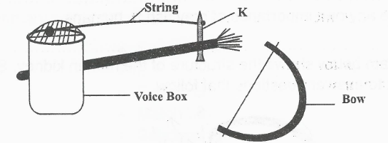

37. State the function of part labeled K.
………………………………………………………………………………………………………….
38. Which group of musical instrument does it belong?
………………………………………………………………………………………………………….
39. What do tapeworms use to feed?
………………………………………………………………………………………………………….
40. Identify the element of PHC which is promoted when children are taught how to prevent diseases.
………………………………………………………………………………………………………….
SECTION B
41a) State any one way how poison is introduced into the body.
………………………………………………………………………………………………………….
b) Mention any two signs of poisoning in humans.
i) …………………………………………………………………………………………………
ii) …………………………………………………………………………………………………
c) Write down one material which can poison the body.
…………………………………………………………………………………………………
42a) Which group of arthropods has ten legs?
………………………………………………………………………………………………………….
b) How is cray fish similar to arachnids in terms of body divisions?
………………………………………………………………………………………………………….
c) Mention any one organism that belongs to the same group of arthropods with cray fish.
………………………………………………………………………………………………………….
d) What are invertebrates used in animal classification?
………………………………………………………………………………………………………….

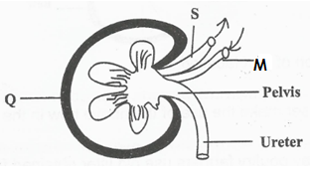
43. The diagram below shows the structure of the human kidney. Study and use it to answer the questions that follow.

a) Name the type of blood carried through blood vessels labeled S and M
i) M ………………………………………………………………………………………………
ii) S ……………………………………………………………………………………………….
b) Name the process which takes place at point Q.
………………………………………………………………………………………………………….
c) Give any one way of maintaining the proper working of the above organ.
………………………………………………………………………………………………………….
44a) Identify any one primary sex change that occurs in both adolescent boys and girls.
………………………………………………………………………………………………………….
b) State one advantage of secondary sex characteristics.
………………………………………………………………………………………………………….
c) Why are adolescent girls more vulnerable to HIV than the boys?
………………………………………………………………………………………………………….

45. A primary seven candidate was provided with the following materials;
a. soil sample
b. spoon
c. water
d. saucepan
Explain the four steps a candidate went through to find out that soil contains humus.
a) ………………………………………………………………………………………………….
b) ………………………………………………………………………………………………….
c) ………………………………………………………………………………………………….
d) ………………………………………………………………………………………………….
46. The diagram below shows a biogas digester. Use it to answer questions that follow.
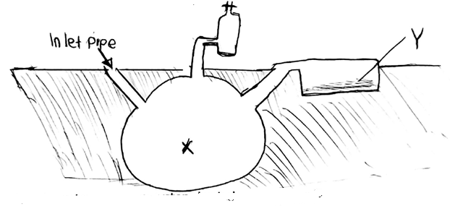

a) Why is the above system buried underground?
………………………………………………………………………………………………………….
b) Name two materials which can be used in part X.
i) ………………………………………………………………………………………………….
ii) ………………………………………………………………………………………………….
c) State the importance of material Y to a farmer.
………………………………………………………………………………………………………….
47 a) A child has swollen neck, state the deficiency disease a child is suffering from.
………………………………………………………………………………………………………….

b) State any one way of preventing the deficiency disease in (a) above.
………………………………………………………………………………………………………….
c) Give any two other mineral deficiency diseases in humans.
i) ………………………………………………………………………………………………….
ii) ………………………………………………………………………………………………….
d) Write one importance of preserving food.
………………………………………………………………………………………………………….
48. The diagram below shows a craw bar. Study and use it to answer questions that follow.
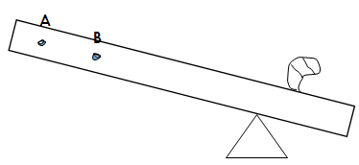

P

a) Which class of lever does the above machine belong to?
………………………………………………………………………………………………………….
b) Using an arrow, show the direction of effort force on the diagram.
c) Name part labeled P.
………………………………………………………………………………………………………….
d) Which of the two points, A and B would one handle to use less effort?
………………………………………………………………………………………………………….

49a) State any one reason why humans carry out these activities before milking.
i) Washing the udder with warm water
………………………………………………………………………………………………………….
ii) Cleaning the milking containers.
………………………………………………………………………………………………………….
b) Mention two breeds of cattle which are kept for milk production.
i) ………………………………………………………………………………………………….
ii) ………………………………………………………………………………………………….
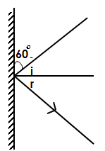
50. Study the diagram below and use it to answer questions that follow.

P
a) Using letter M, show the position of source of light on the diagram.
………………………………………………………………………………………………………….
b) What is the relationship between angle i and angle r.
………………………………………………………………………………………………………….
c) Give a reason why we can see a clear image in plane mirrors.
………………………………………………………………………………………………………….
d) Calculate the value for the angle of reflection.

51. The diagram below shows parts of a flower. Study and use it to answer questions that follow.

M

N
a) State the processes that take place in parts labeled M and N.
i) M ………………………………………………………………………………………………
ii) N ……………………………………………………………………………………………….
b) Identify the part which protects the flower in bud stage.
………………………………………………………………………………………………………….
c) What name is given to part of a flower above?
………………………………………………………………………………………………………….
52. The table below shows diseases and the way they are spread. Study and match correctly.
Sense | Organ
Seeing | Tongue
Hearing | Eyes
Touching | Ears
Tasting | Skin
a) seeing ………………………………………………………………………………………..
b) hearing ……………………………………………………………………………………….
c) touching ……………………………………………………………………………………
d) tasting ………………………………………………………………………………………...

53. The following are steps under which a seed undergoes when growing;
They are arranged in a wrong order. Re-write them in their correct order
a) The shoot grows out
b) The seed allows in water of air
c) The seed is planted
d) The radicle grows out
Correct order
a) ………………………………………………………………………………………………….
b) ………………………………………………………………………………………………….
c) ………………………………………………………………………………………………….
d) ………………………………………………………………………………………………….
54. The diagram below shows the illustrations of the properties of magnets. Study and use them to answer questions that follow.
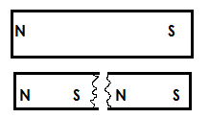
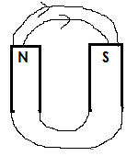
A B

a) Identify the property of magnet illustrated in diagrams A and B.
A……………………………………………………………………………………………………
B…………………………………………………………………………………………….………
b) How are magnets important to the following?
i) Doctor ………………………………………………………………………………………
ii) People using a maximum and minimum thermometer.
………………………………………………………………………………………………………….
55 a) State two characteristics of essential drugs
i) …………………………………………………………………………………………………
ii) ………………………………………………………………………………………………….
b) Write down one example of an essential drug.
………………………………………………………………………………………………………….
c) Of what effect is taking an under dose to an individual?
………………………………………………………………………………………………………….
WISHING YOU SUCCESS!!!!

